The following was announced during our church service on June 4, 2023.

TO: MEMBERS AND FRIENDS OF SHORELINE UNITED METHODIST CHURCH

SUBJECT: MUSIC AND PRAISE TEAM OPPORTUNITY

Our musician accompanist, Johnson Gouvea, is downsizing and needs to sell his professional grand piano by the end of July. He has offered to sell it to the church for $10,000, which is significantly less than its value and is superior in sound and quality to our current one.

We are excited about our music ministry and the Praise Team that continued to thrive and grow under the leadership of Sandre’ Geyen. To further enhance our music worship, we are proposing to undertake a fundraiser to purchase Johnson’s piano as a tribute to Sandre and to Anita Proudfoot, our previous Praise Team Leader who donated the current piano. We will try to find a suitable home for it as part of our effort.

This money would not come out of our church operating funds but would be strictly from donations from friends and family who would like to contribute. If we fall short of the amount needed, donors would be entitled to their money back if they choose. If we receive more than needed, it will go into a special fund for our music ministry.

We have pledge cards today for those who would like to contribute to this effort. Feel free to send a contribution with a designation for the piano fund.

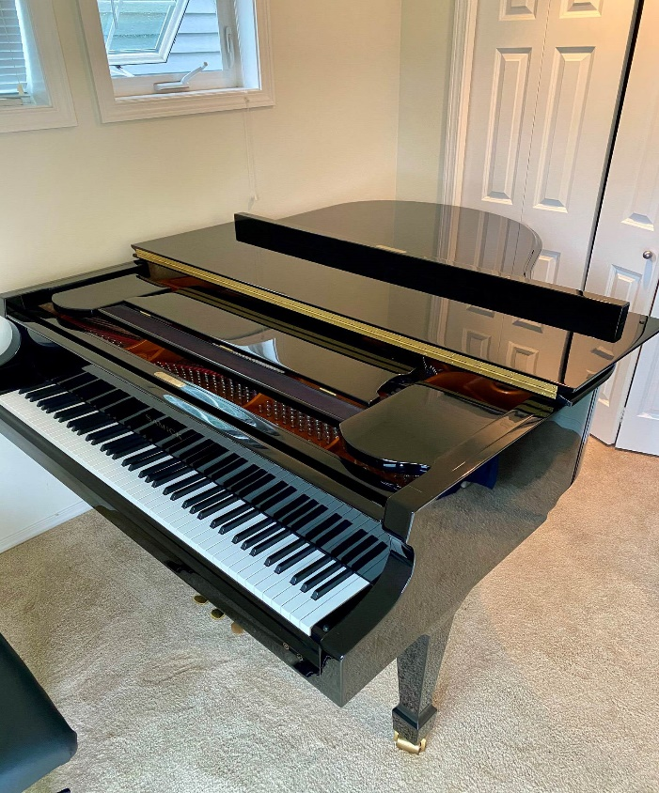

Special Committee Members:

· Kitty

· Nellie Ann

· Nancy

· Meredani

· Johnson

· Paul

· P. Kevin

Click the link o donate to the

[Piano Purchase Fund](https://579b28b9.churchtrac.com/give).